Renju lesson on May 3, 2001

Hello all! Welcome to Online Renju Class. We will continue our study about d11.
The topic is the 13th move that has been popular past 4 years. The 13th move is so new that none of the world renju books include it yet. Even the famous “click of stone” book doesn’t include that 13th move because the book was published early in 1997, before the 13th move appeared in public. So you do not have many places to learn it from. Therefore I suggest you to pay attention, take notes, and ask questions if necessary, because this lesson is your only chance to learn about it. We will start checking several blocks here. Which 14th moves are you interested to learn about? The short conclusion about the situation here – black wins surely in case of any 14th move except 14-j7. And in case of 14-j7, black has powerful advantage, but sure win is not so easy to be proved. However, I believe the win exists here too. I agree with ASV idea – to check other 14th moves first and then study about 14-j7.
First, 14-j9. It has been one of the oldest moves in the theory of this variant. How does black attack here?
There are several positions where we cannot use VCT, but we must develop further.
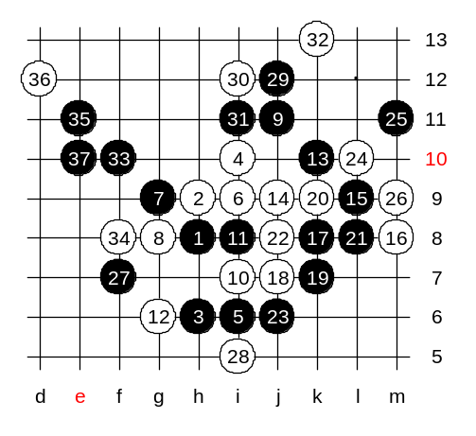
After 26th move, black cant have sure win attack because of white defense material at f7. The idea would be following: Black has two promising sides – upper side and lower side. We only need to check if the f7 bothers us or not. Lets take the f7 first, and eliminate all white structures. Now, white must defend below, am I right? After the white block, black can take the key point j12. Now it seems that black will win soon. Black has enough space and free lines. Black can now easily attack towards left side space. The further moves are simple. Anyone can easily prove black win here.
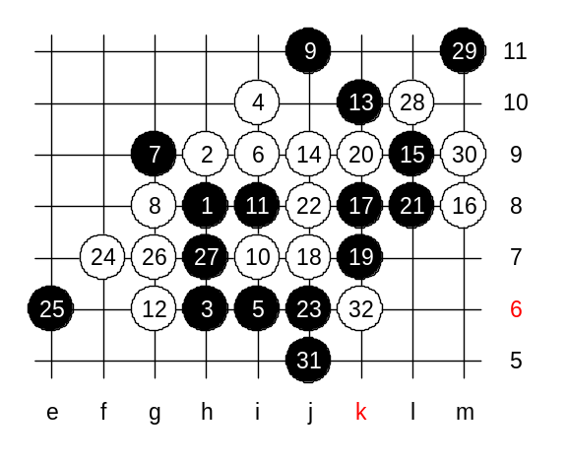

Now, white takes f7 and g7 points first. Can black win now? Let’s see.

This is the advanced level homework. Please find the black win.

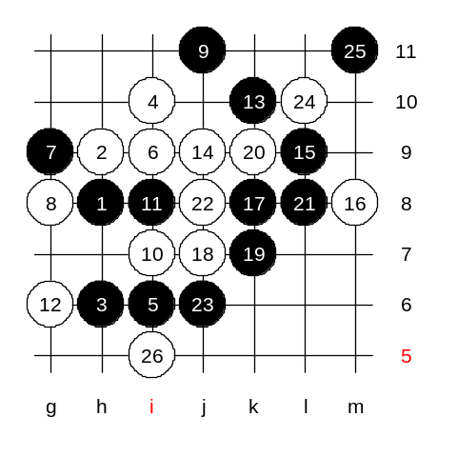
This is the medium level homework. Please find the black win here.

